Holiday Shoppes 2026

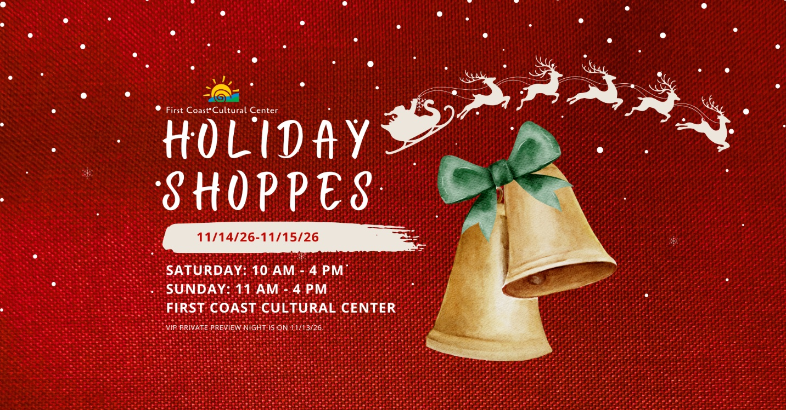

Application Dates
Early Bird Special 20% discount if registered by August 31, 2026. NO EXCEPTIONS.
All applications and payment must be submitted by September 30, 2026

Event Dates and Times
November 13, 2026 Private Preview 5:30 pm – 7:30 pm
November 14, 2026 Open to the Public 10:00 am – 4:00 pm
November 15, 2026 Open to the Public 11:00 am – 4:00 pm

First Coast Cultural Center
6000B Sawgrass Village Circle
Ponte Vedra Beach, FL 32082

2026 Application and Agreement
Please read carefully as our policies have changed.

(PLEASE PRINT)

Vendor/Company Name: _____________________________________________________________________________________

Contact Name: ____________________________________________________________________________________

REQUIRED: Email Address:
____________________________________________________________________________________

REQUIRED: Website Links (Please include, Facebook, Etsy, Instagram, etc. and social media handles):

_____________________________________________________________________________________

_____________________________________________________________________________________

_____________________________________________________________________________________

_____________________________________________________________________________________

Mailing Address: ____________________________________________________________________________________
____________________________________________________________________________________

Phone Number: ____________________________________________________________________________________

Day of Event Contact Name & Number: ____________________________________________________________________________________

_____________________________________________________________________________________

Description of Merchandise (Please attached digital images to this application):
_____________________________________________________________________________________

_____________________________________________________________________________________

_____________________________________________________________________________________
_____________________________________________________________________________________

_____________________________________________________________________________________

Booth Options

Inside (Both Days + Private Preview):

- Single Booth (One table / equivalent) $280/ 20% $225

- Double Booth (Two tables / equivalent) $499/ 20% $400

- Triple Booth (Three tables / equivalent) $850/ 20% $680

Outside 11/14 or 11/15 (One Day, No Private Preview):

- Single Booth (One table / equivalent) $100/ 20% $80

- Double Booth (Two tables / equivalent) $175/ 20% $140

- Food Truck $100/ 20% $80 Indicate your preferred day(s): ______________

*You may pay for a booth on both days. Set-up and tear-down is required on both days outside.

Payment Information

Upon acceptance of this Agreement, you will receive a link to pay online, which is due within 7 days. You may also call 904.280.0614 with your credit card information or pay via check by mail to First Coast Cultural Center, Attn: Kimberly Sheridan, 6000B Sawgrass Village Circle, Ponte Vedra Beach, FL 32082 once approved. Payments are non-refundable. Confirmation of your submission will be emailed to you.

Set-Up and Break-Down

Booth set-up will be during the day on Friday, November 13, 2025, from 10:00 a.m. to 4:00 p.m. Booth set-up must be completed by 4:00 p.m. for our private preview that night.

Packing up and breaking down will begin on Sunday, November 15 at 4:00 p.m. and not prior. First Coast Cultural Center is not responsible for booth set up and breakdown.

Details

You are responsible for providing tablecloths, tabletop displays, fixtures, and extension cords. Tables are provided, if requested, for inside spots ONLY and on a first-come basis. You are not permitted to touch or move artwork. Anything that you wish to hang on the walls must be approved by FCCC staff. Outdoor vendors will be responsible for bringing their own tables, setting up, and breaking down each day. First Coast Cultural Center is not responsible for any vendor inventory or personal items. Booths will be lit adequately. If you need further lighting, please bring your own.

First Coast Cultural Center does not guarantee product sales. Booth placement is based on product type. First Coast Cultural Center will not accept booth placement requests.

Help us market the event!

We ask for your partnership in promoting this event to your clients and marketing base. You will be provided with marketing materials for this event. Tag us on social media and share all our professionally created advertisements. We can also provide you with printed materials for your clients.

Commissions

There will be a $5 suggested donation for shoppers throughout the duration of Holiday Shoppes, collected by and benefitting First Coast Cultural Center.

As a vendor, you agree to pay First Coast Cultural Center an 18% commission on all gross sales and special orders made at/during the 2026 Holiday Shoppes event. Furthermore, you understand and agree to provide First Coast Cultural Center staff with a full and accurate summary of remittance of total gross for all sales and all commission owed. The amount must be paid prior to leaving the premises on Sunday, November 16, 2026. Interest of 10% will be charged per week if not paid.

Time to Sign!

By signing/typing your name here, you agree to all the terms in this application and contract.

Print Name Signature Date

We hope you will join us to make this year’s Holiday Shoppes the most spectacular yet!

Sincerely,

Silvia Romero
Executive Director
904.280.0614
sromero@firstcoastculturalcenter.org

